COMPARISON OF THE QUALITY FACTOR /BER OF THE PHOTODIODE CENTERED /NOT CENTERED AT MAXIMUM POWER

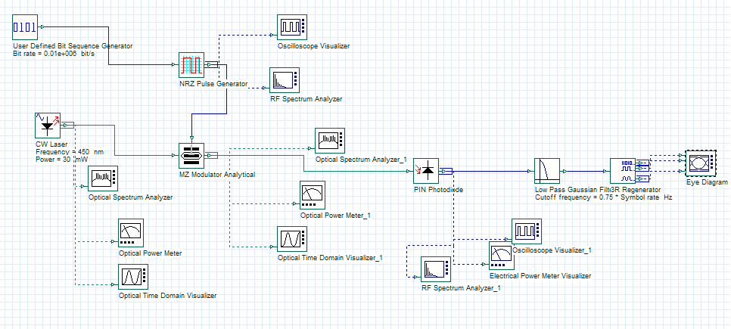

Simulation diagram

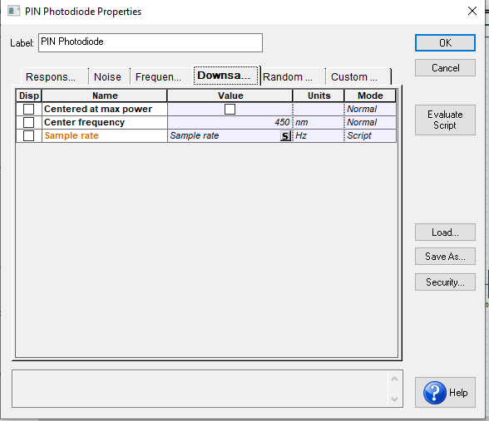

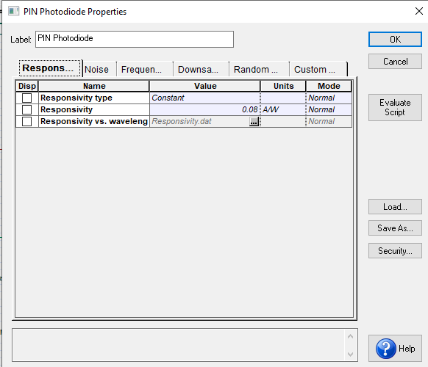

When the photodiode was not centered at maximum power
- Frequency of 450nm, responsivity of 0.08A/W

Data Rate | Optical power (W) | Electrical Power (W) | Q factor | BER
10kbps | 17.105mW | 3.271μW | 280.344 | 0
100kbps | 17.105mW | 3.271μW | 258.13 | 0
1Gbps | 17.105mW | 3.271μW | 250.846 | 0

When the photodiode was centered at maximum power
- Frequency of 450nm, responsivity of 0.08A/W

Data Rate | Optical Power (W) | Electrical Power (W) | Q factor | BER
10kbps | 17.105mW | 1.893mW | 3.40953 | 0.00031567
100kbps | 17.105mW | 1.581μW | 2.28117 | 0.011011
1Gbps | 17.105mW | 3.271μW | 250.124 | 0

