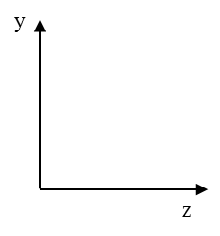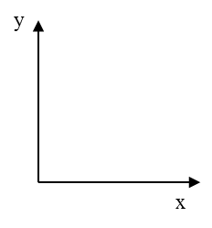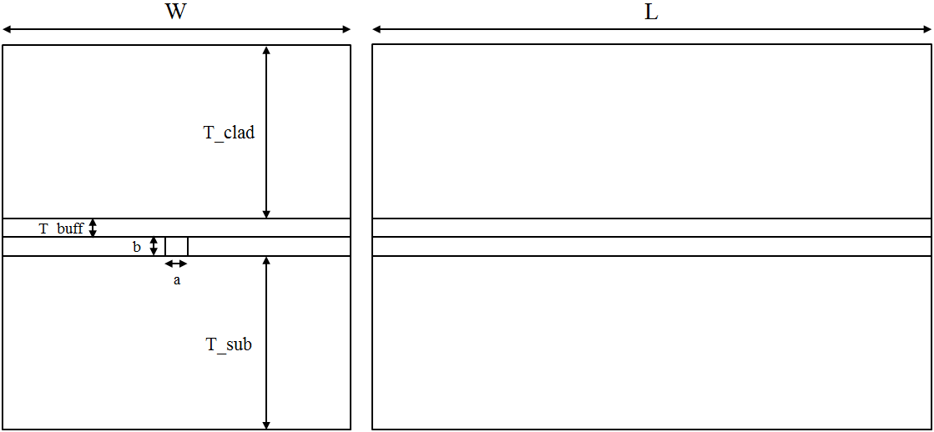

ncore = 1.6263

ncladd = 1.512

nsub = 1.54

nprism = 1.74

|  |  |
| --- | --- |
| Parameters | Dimensions |
| L | 20 mm |
| W | 500 µm |
| T_clad | 200 µm |
| T_buff | 2.2 µm |
| a | 2.6 µm |
| b | 2 µm |
| T_sub | 200 µm |

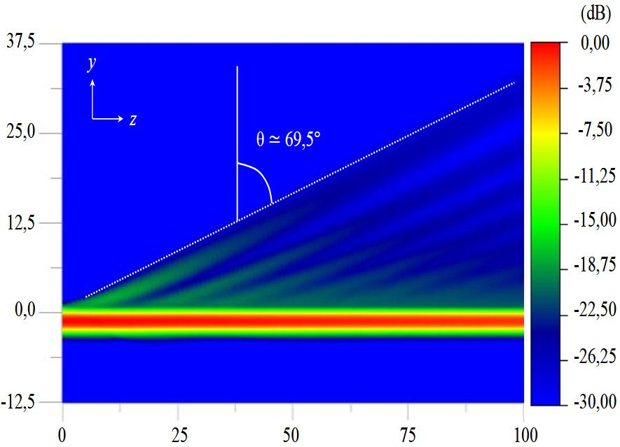

Z

Y