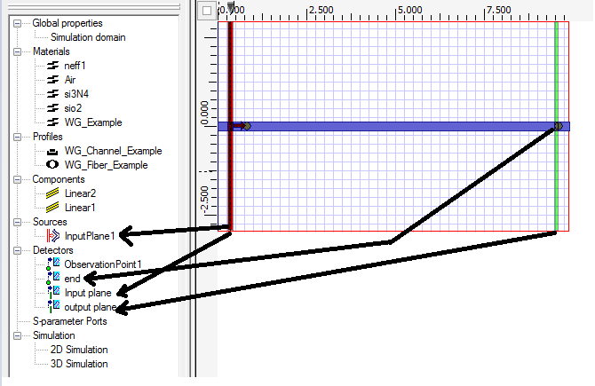
Fig 1. Layout diagram
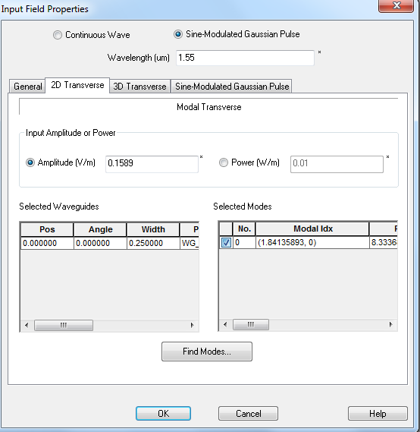
Fig 2. Input Field Properties
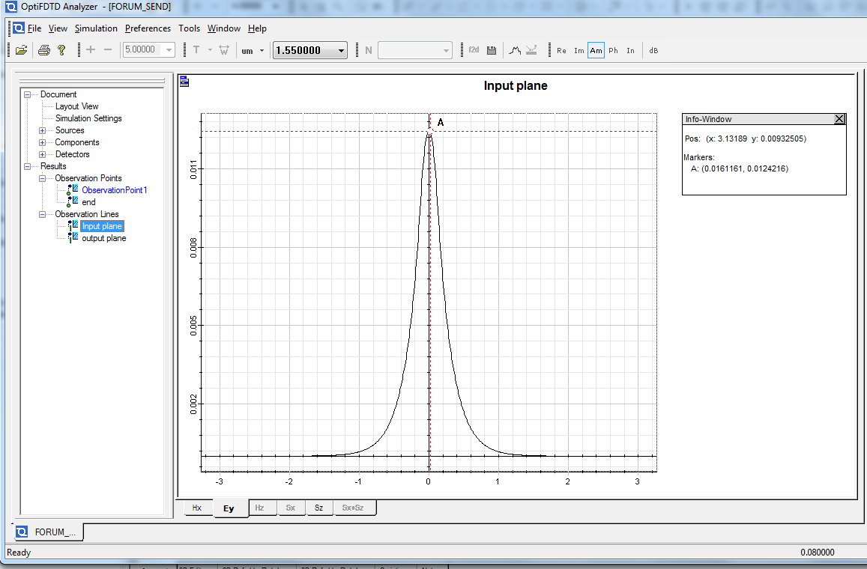
Fig 3. Input Plane

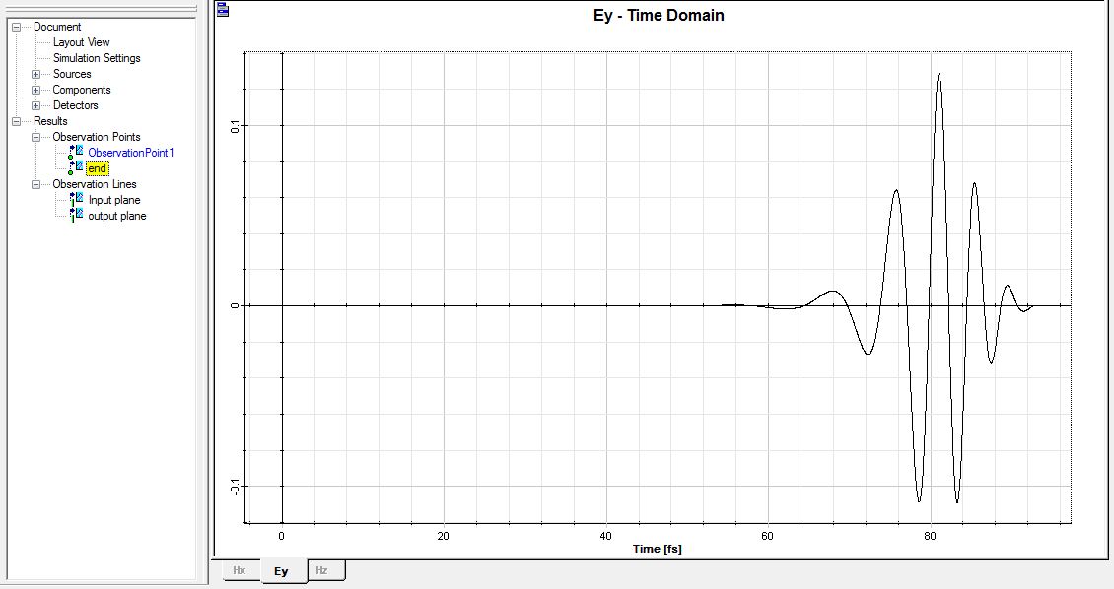
Fig 4. Observation point at the end of the waveguide

Hi Sir,
As shown in Fig 2. I am giving Input Field amplitude of 0.1589 but in Fig. 3 as you can see my Input Field amplitude is shown by point A is 0.0124216. Why I am getting this difference?

