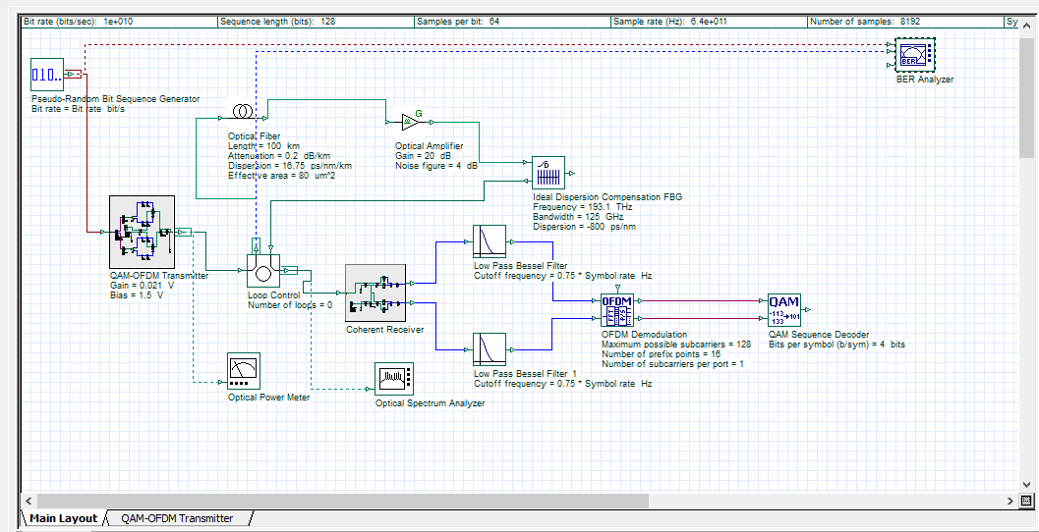
Complete 4-QAM CO-OFDM Pro Compensation Dispersion
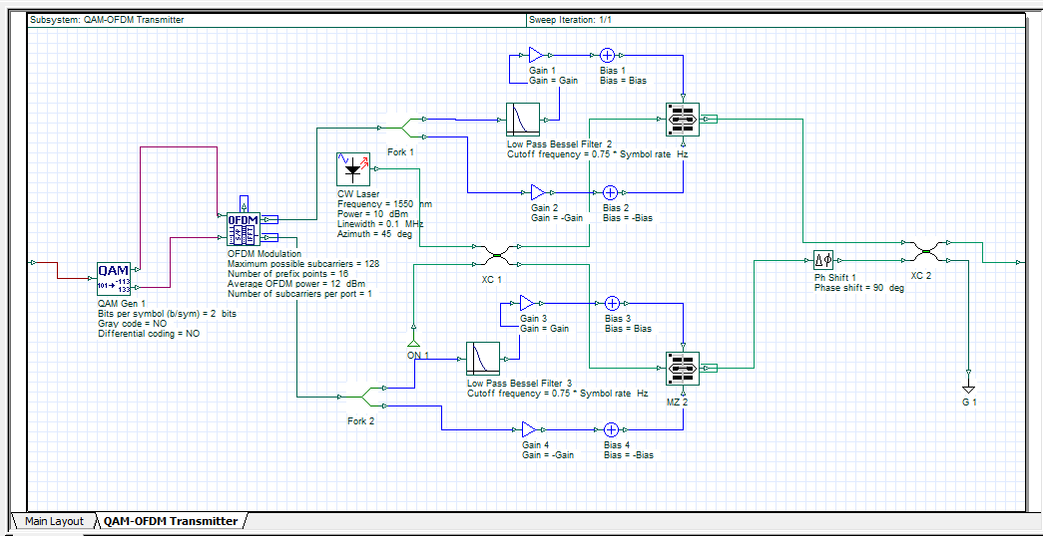
Transmitter Architecture
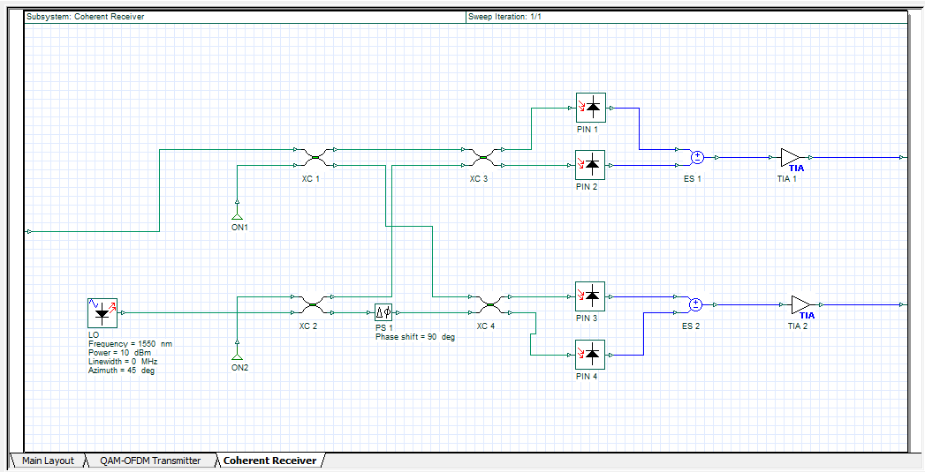
Receiver Architecture.

