4.3 Effect on Fiber Losses, α=0.35 dB/KM
L=10 KM
4.3.1: Input graph
Figure 4.3.2: Output graph

L= 20KM
Figure: 4.3.3: Input graph
Figure: 4.3.4: Output graph
L= 30KM
Figure 4.3.5: Input graph
Figure 4.3.6: Output graph
4.4 Effect on nonlinearity (SPM) L=10KM
Figure 4.4.1: Graph of fundamental of soliton
Figure 4.4.2: Effect of nonlinearity of soliton
L= 20KM
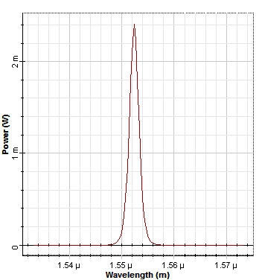
Figure 4.4.3: Input graph of fundamental of soliton
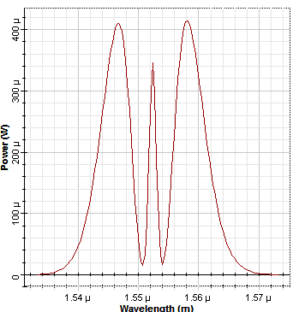
Figure 4.4.4: Effect of nonlinearity of soliton

L=30 KM
Figure 4.4.5: Input graph of fundamental of soliton
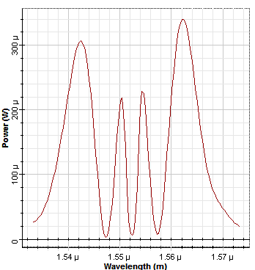
Figure 4.4.6: Effect of nonlinearity of soliton
4.5 Effect of Group Velocity Dispersion (GVD) L=10KM
Figure 4.5.1: input graph
Figure 4.5.2: Output graph
L=20KM
Figure 4.5.3: Input graph
Figure 4.5.4: Output graph
L=30KM
Figure 4.5.5: Input graph
Figure 4.5.6: Output graph

