Material wafer: air ; Material cylinders: PBG_atom
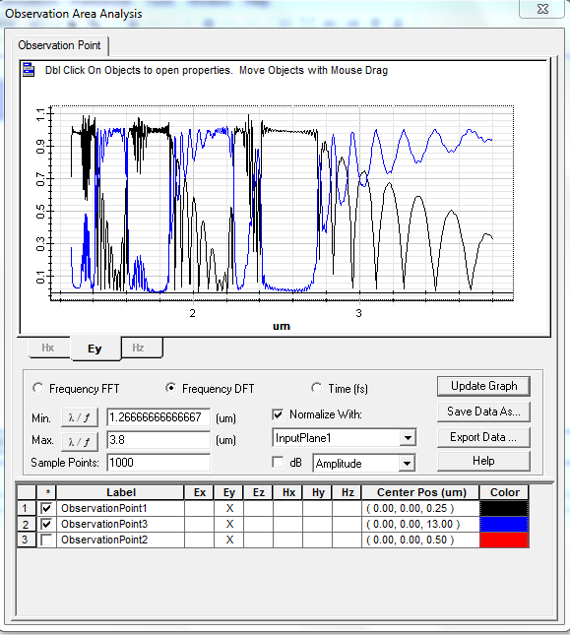

Material wafer: PBG_atom; Material cylinders: air
