This figure for the theoretical calculations

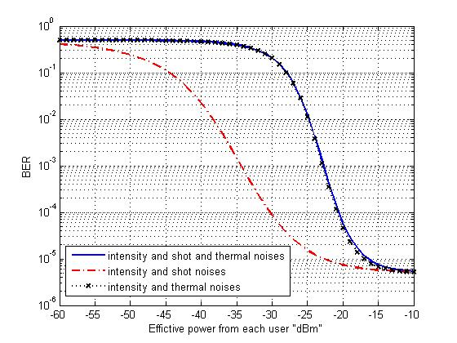

I want to compare this theoretical curve to the simulation one from optisystem like the next figure.

