Note: Please take screenshots of any error messages, should you receive any.
- Download this file: https://s3.amazonaws.com/download-us/HASP_Drivers/Sentinel_LDK_Run-time_cmd_line.zip
- Extract the downloaded file:
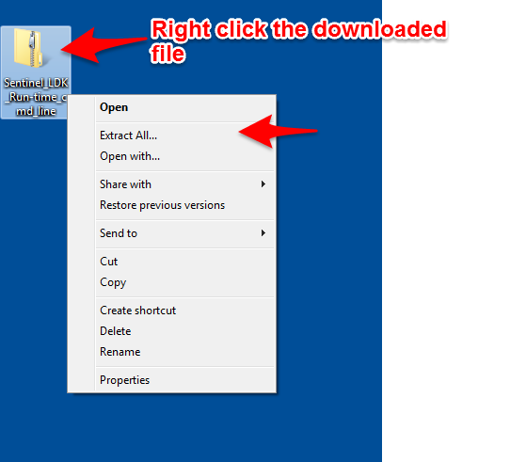
- Click Start
- Type cmd into the search bar and hit Enter or select cmd from the list
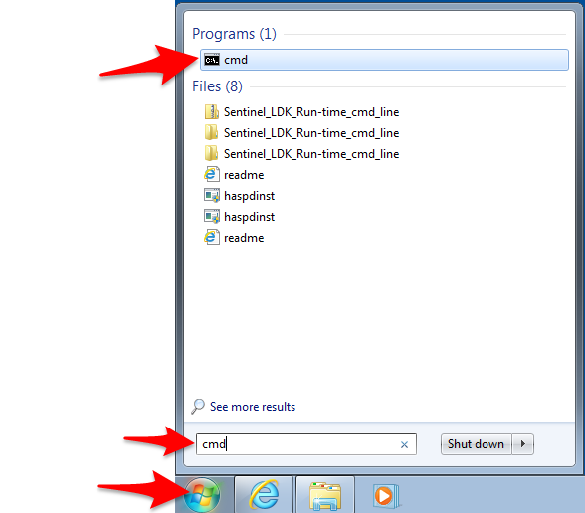
- Drag and drop the “haspdinst.exe” file from the folder with the extracted files from step 1 into the command prompt window, leave a space and then type “-fr –kp –purge”
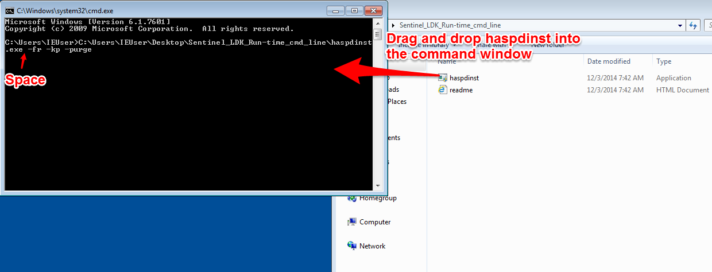
- Hit Enter
- Click Yes in the User Account Control window:
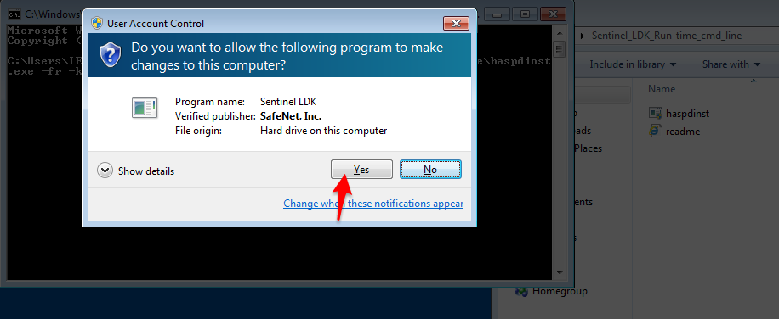
- Click OK in the Sentinel Run-time Environment Installer window:
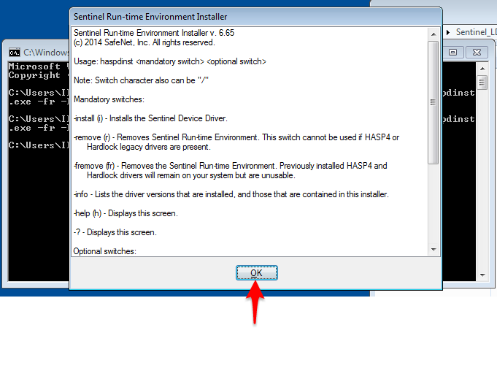
- Restart your computer. Note: If you have a USB key, make sure it is unplugged.
- Login with administrator privileges
- Important: disable your antivirus
- Click Start
- Type cmd into the search bar and hit Enter
- Drag and drop the “haspdinst.exe” file from the folder with the extracted files from step 1 into the command prompt window, leave a space and then type “-i”
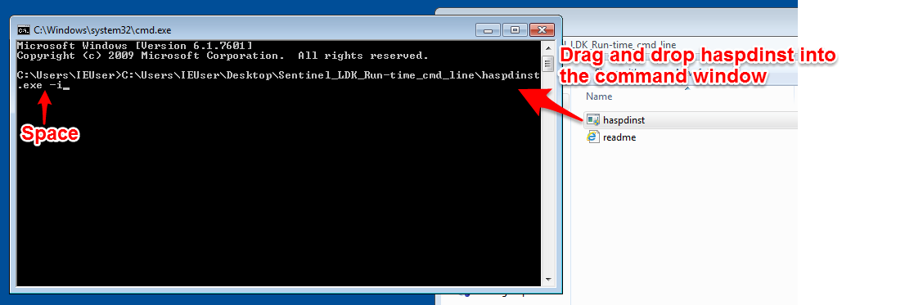
- Hit Enter
- Click Yes in the User Account Control window:
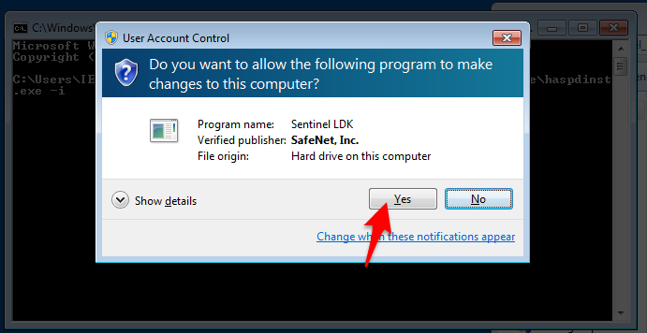
- Click OK in the Sentinel Run-time Environment Installer window:
- Open your browser and take a screenshot of http://localhost:1947/_int_/features.html
If you are able to access http://localhost:1947/_int_/features.html and you can see a page similar to the one below, you should now be able to run the software.
